otoorashid@yahoo.com,

Phone: 0209985974

23rd December, 2020

The Senior Assistant Registrar

Examinations Office

KNUST

Dear Sir/ Madam,

**REQUEST FOR AN ATTESTATION LETTER**

Due to the necessity of an attestation letter as part of the prerequisite of supporting documents with regards to a job application, I therefore humbly request for the above-mentioned letter from the School

Below are my details:

**Name:** Rashid Nii Aryee Otoo

**College:** College of Engineering

**Course:** Electrical/Electronic Engineering

**Students Number:** 31872357

**Registration Number on Certificate:** 82327

**Index Number:** 8232705

I hope to hear from you at your earliest convenience

Thank you.

Yours faithfully,

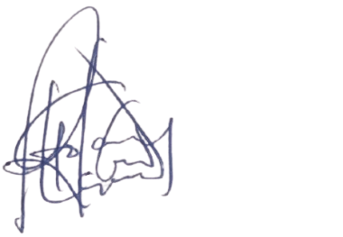

Otoo, Rashid Nii Aryee